Conceptual VECP Submission – Process Flowchart 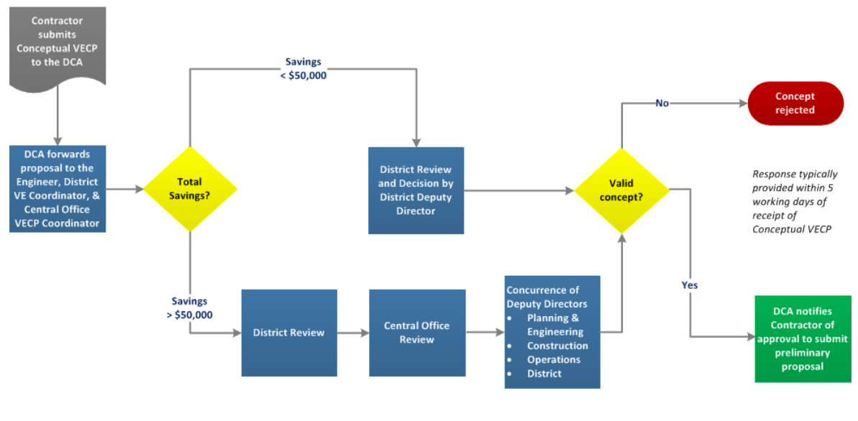
Savings > $100,000
Savings < $100,000

Preliminary VECP Submission – Process Flowchart
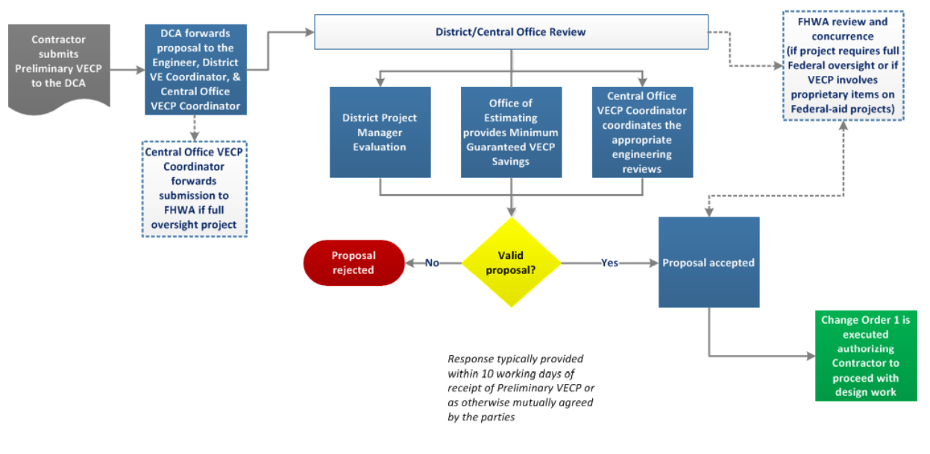

Final VECP Submission – Process Flowchart
